Exercises with Functions – Unit 3.3
These exercises focus on creating and using our own functions:
- def - defining a function
- parameters
- return values
- calling a function

Create Python programs to do the following:
1. Create a function called hypotenuse that calculates the hypotenuse of a right-angle triangle given the other two sides.
save as funEx1.py

2. A palindrome is a word that reads the same both forward and backwards. Create a function called palindrome that takes a single word as a parameter and returns True if the word is a palindrome and False otherwise.
save as funEx2.py
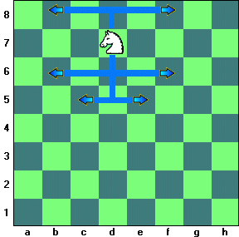
3. Knights in chess move in an L shape. They go 2 in one direction then one space at a 90 angle, as the diagram shows. Create a function called knightMove that takes in the current location (row, col) of a knight on the chess board and returns a list of tuples (row, col) of all possible places the knight can move.
save as funEx3.py

4. As you know the persistence of a number is the number of steps it takes to get a one-digit number when separating the digits and multiplying them together. What you may not have noticed is that persistence is inherently recursive. The persistence of any one-digit number is zero. The persistence of any other number is one plus the persistence of the digits multiplied together. Create a recursive function called persistence that computes the persistence of any whole number.
save as funEx4.py

